

**SECURED-T**

**Student Guide**

**Version 1.0**

**[03 August 2017]**

**Contents**

**LIST OF ILLUSTRATIONS ii**

**Connect To The Network 1**

**Download The Required Program 1**

**Register Using The CSI Program 2**

**Log In To The StudentSectT 4**

**Logging In Errors 4**

**Navigating Through StudentSecT 7**

**Submissions 7**

**Logout 9**

**Exiting The Program 9**

#### 

#### 

#### **LIST OF ILLUSTRATIONS**

**Figures**

Figure 1: Uncheck Auto Connections

Figure 2: Select Network

Figure 3: Download prompt

Figure 4:Store CSI program

Figure 5: Proceeding From Downloads

Figure 6: CSI Program

Figure 7: Invalid Input Error Message

Figure 8: Connection Error Message  
Figure 9: Successfully Connected Message   
Figure 10: Placement Of CSI  
Figure 11: Login Screen

Figure 12: Invalid Exam Code Error   
Figure 13: Invalid Registration Error   
Figure 14: Logged In Error   
Figure 15: Disconnected Error  
Figure 16: Announcement Page  
Figure 17: Submission Page  
Figure 18: Submission Error Message  
Figure 19: Submission Successful Message  
Figure 20: Pop-up Confirmation Warning

#### 

#### 

#### 

#### 

#### **Connect To The Network**

As a student, the first step to enter into our system is to connect to our network.

1. On your WiFi settings, make sure to uncheck the auto connection to other networks.

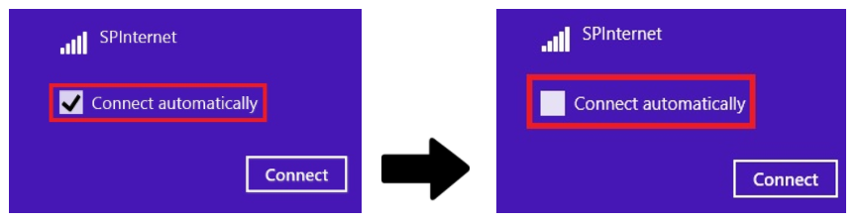

**Figure 1: Uncheck Auto Connections**

1. On your WiFi settings, search for the SSID of the router. Choose either ***Sectest1*** or ***Sectest2*** and check the box to auto connect so as to stay connected***.***

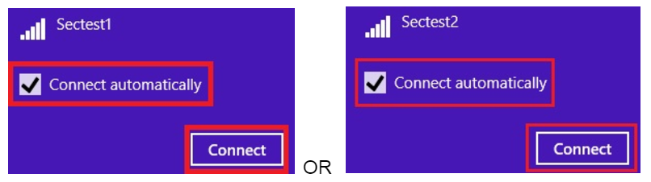

**Figure 2: Select Network**

1. Then, key in the passcode for the respective SSID.
   * SSID: ***Sectest1***

Passcode: ***sectest1***

* + SSID: ***Sectest2***

Passcode: ***sectest2***

#### **Download The Required Program**

Navigate to our student web application, StudentSecT.

1. Browse to ***192.168.237.138/StudentSecT***.
2. If there is a prompt to auto download our CSI program, accept the download.



**Figure 3: Download prompt**

1. Store it where it is easily accessible for you, eg. Desktop

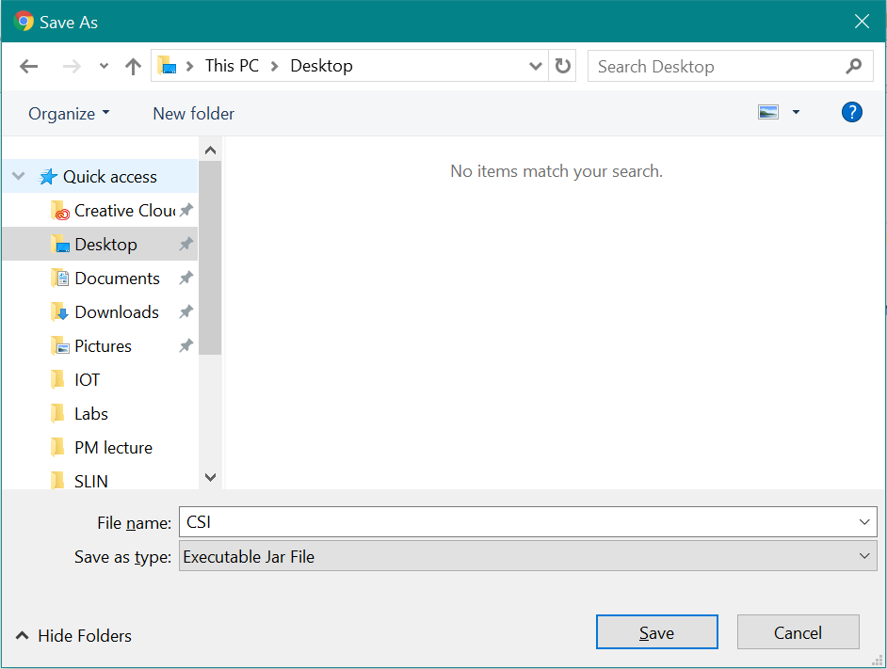

**Figure 4: Store CSI program**

1. Then, click on ‘Proceed’.

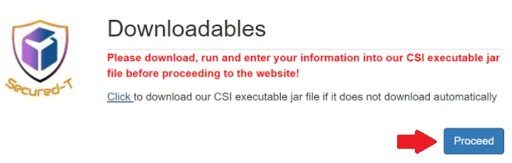

**Figure 5: Proceeding From Downloads**

#### **Register Using The CSI Program**

Before logging into the website, you will have to register your admission number into the CSI program to be authorized.

1. Double-click on the CSI jar file to run it.
2. Enter your admission number, (eg. P1234567) into the field and click “Connect”.

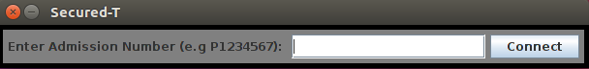

**Figure 6: CSI Program**

1. If you receive the following error message, please note that you need to enter exactly 8 characters into the field. Close the program and re-run it.

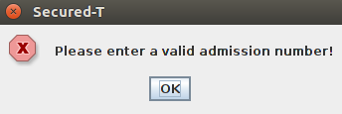

**Figure 7: Invalid Input Error Message**

1. If you receive the following error message, please inform the lecturer.

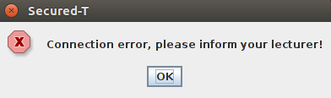

**Figure 8: Connection Error Message**

1. Once you have clicked “Connect”, there will be an acknowledgement message that says you have been connected. Click ‘OK’.

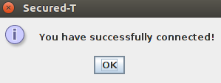

**Figure 9: Successfully Connected Message**

*\*\*Please note: Once you have successfully connected to our system, the “Connect” button will be disabled and will not be able to it anywhere.* ***Please place the frame at a position on your screen that will not hinder you when doing your assessment.*** *However, you should be authorized to log in to the* ***StudentSecT*** *site.*

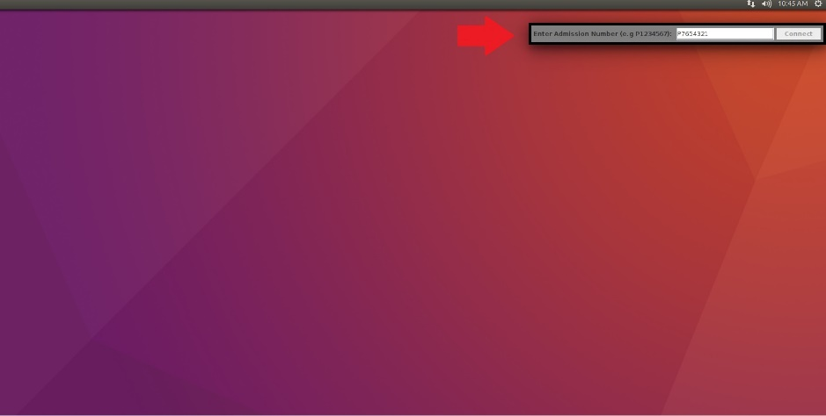

**Figure 10: Placement Of CSI**

#### **Log In To The StudentSectT**

Once you have registered, you can now use the StudentSecT site. It is very important for you to know that you are only allowed to **login once** and **logout** **only at the very end** to be on the safe side of avoiding login errors.

1. Log in using your admission number, the exam code that will be written on the whiteboard and your table number assigned to you and click “Enter”.

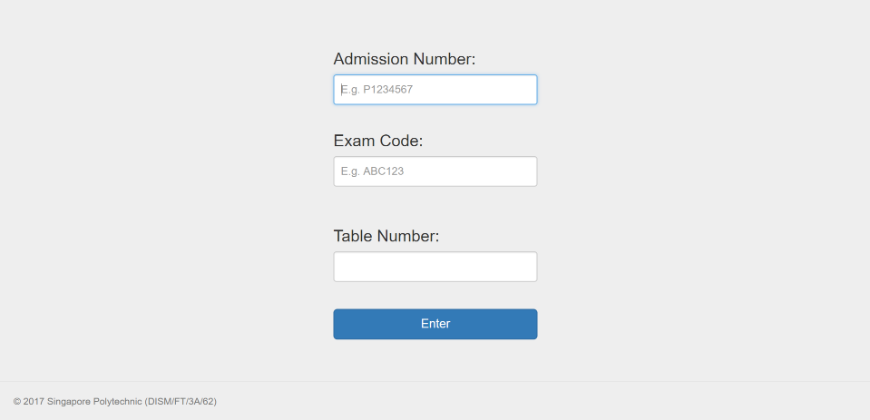

**Figure 11: Login Page**

#### **Logging In Errors**

There may be 4 instances of error messages you may receive if you have been unsuccessful. Here is what to do:

1. If you receive the following error, this means that you have typed the wrong exam code. Simply retype the correct code and you can log in.

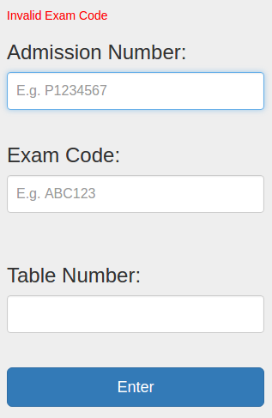

**Figure 12: Invalid Exam Code Error**

1. If you receive the following error, this means that you have not registered your admission number through the CSI program beforehand. Register yourself to the CSI first.

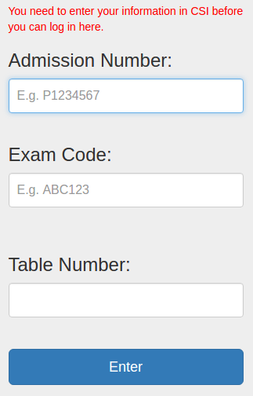

**Figure 13: Invalid Registration Error**

1. If you receive the following error, this means that you have already been logged in. In the case that you have never logged in before but received this error, then it may mean that someone else had logged in as you. Inform your lecturer immediately. However, if you have logged in before and have accidentally closed the browser, you can type in the following link to get back: [***http://192.168.237.138/StudentSecT/announcement.jsp***](http://192.168.237.138/StudentSecT/announcement.jsp)

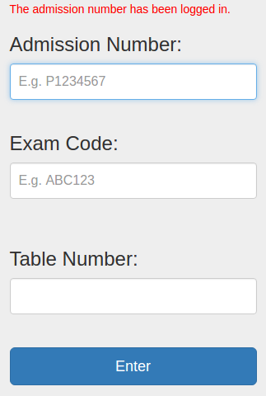

**Figure 14: Logged In Error**

1. If you receive the following error, this means that you have already exited the assessment and you are prohibited from logging in again. It is only a one-time login. Unless you have a valid reason, inform your lecturer. However, they will decide whether or not to allow you access to the assessment again.

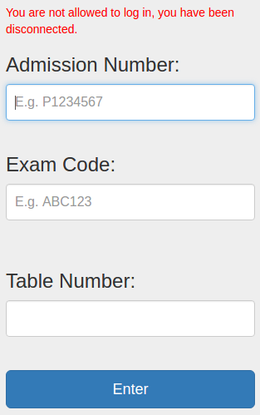

**Figure 15: Disconnected Error**

1. If the reason is valid, you will have to repeat the process of registering with CSI and log in to StudentSecT again.

#### **Navigating Through StudentSecT**

Upon login, **you are highly advised to not use the back button on the browser to backtrack.**

You will see the main page where you can view the announcements from your lecturer for the assessment you are taking. Kindly click on the “Announcements” tab to reload it if you cannot view the allowed domains for the assessment and any new announcements from the lecturer at the start. Then, you can minimize the browser and continue doing your assessment.

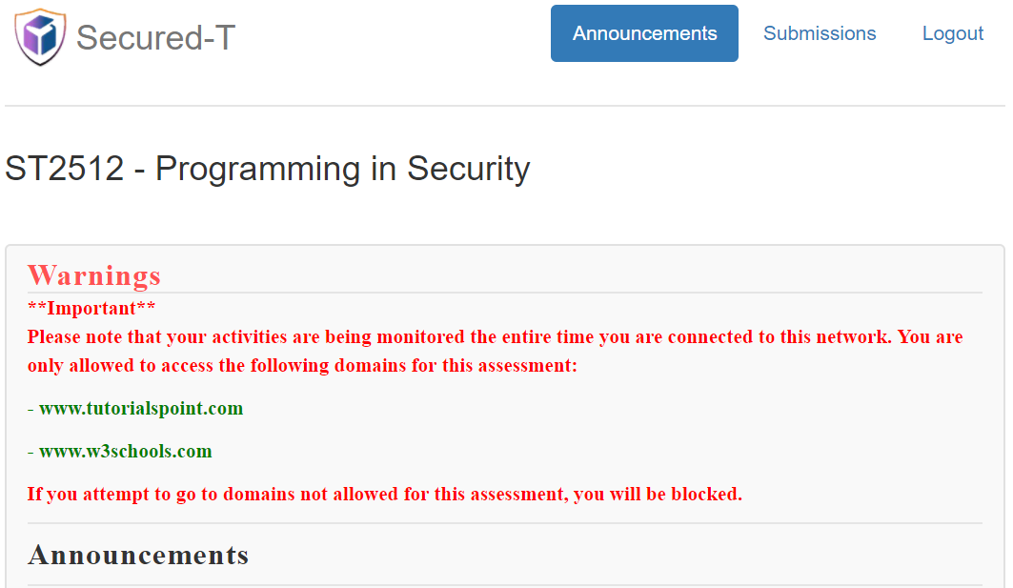

**Figure 16: Announcement Page**

*\*\*Please take note of the warnings and read it.*

You may click on the “Submissions” tab when submitting answers and then proceed to logout.

#### **Submissions**

When you wish to submit the answers, bring up the browser, or if you have closed the browser, navigate to [***http://192.168.237.138/StudentSecT/announcement.jsp***](http://192.168.237.138/StudentSecT/announcement.jsp)and click on the “Submissions” tab.

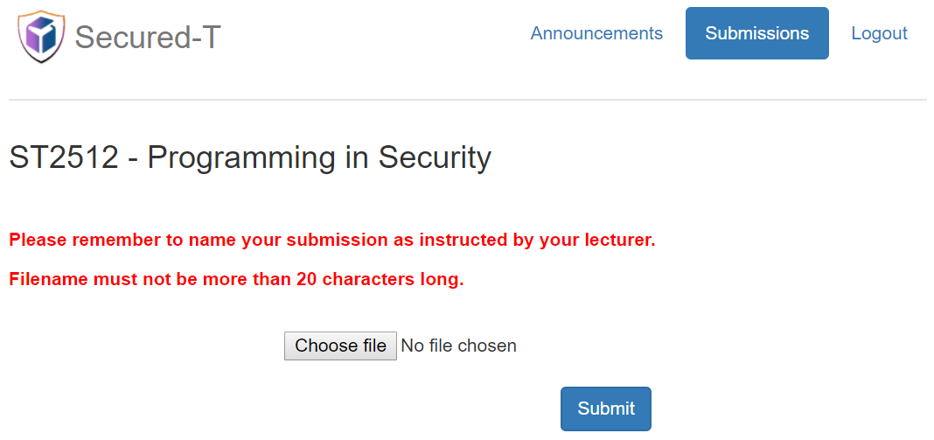

**Figure 17: Submission Page**

1. Click “Choose File” and choose your submission answers with a filename not more than 20 characters in length. If you did not fulfill this requirement, you will receive the following error.

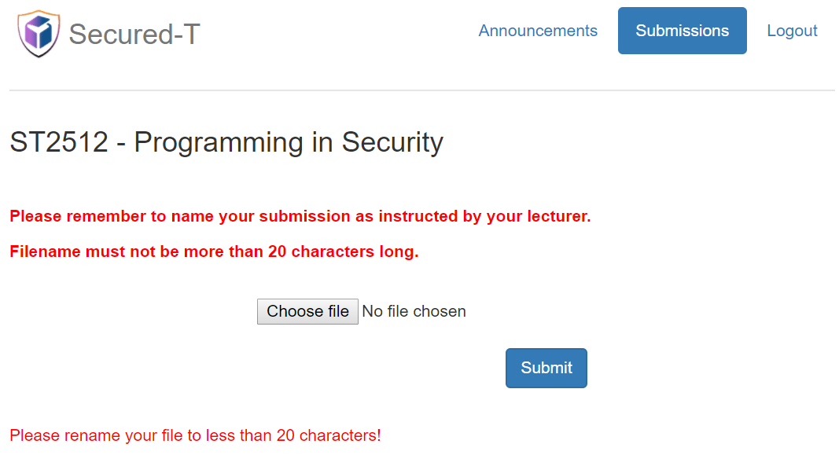

**Figure 18: Submission Error Message**

1. If you are successful, you will be notified.

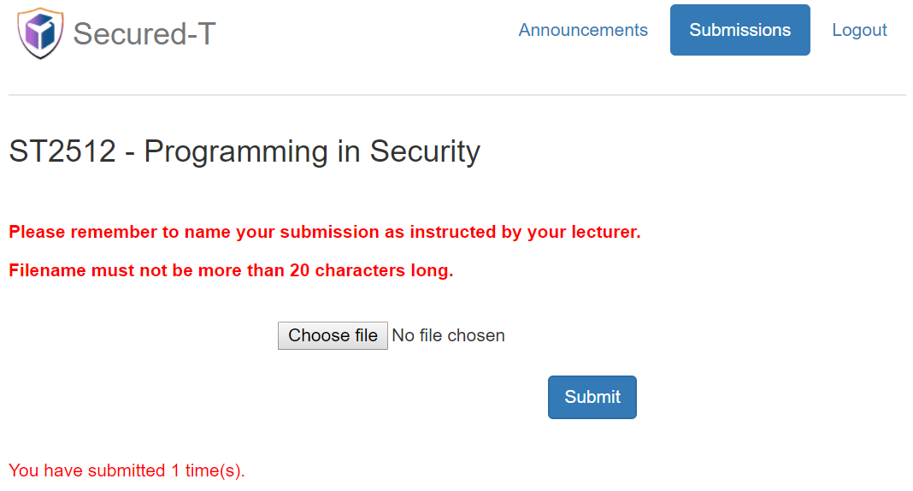

**Figure 19: Submission Successful Message**

1. You may be allowed to submit as many times as you wish until you logout.

#### **Logout**

When you are done submitting your answers, just press the “Logout” tab. There may be a pop-up notification asking for your confirmation to logout.

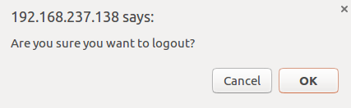

**Figure 20: Pop-up Confirmation Warning**

**Please note: You are only to logout once and will no longer be able to access the assessment. Hence, make sure you click on the button only at the end, once you are ready.

#### **Exiting The Program**

Upon logout, the CSI program will cease and be terminated automatically.

**The End**